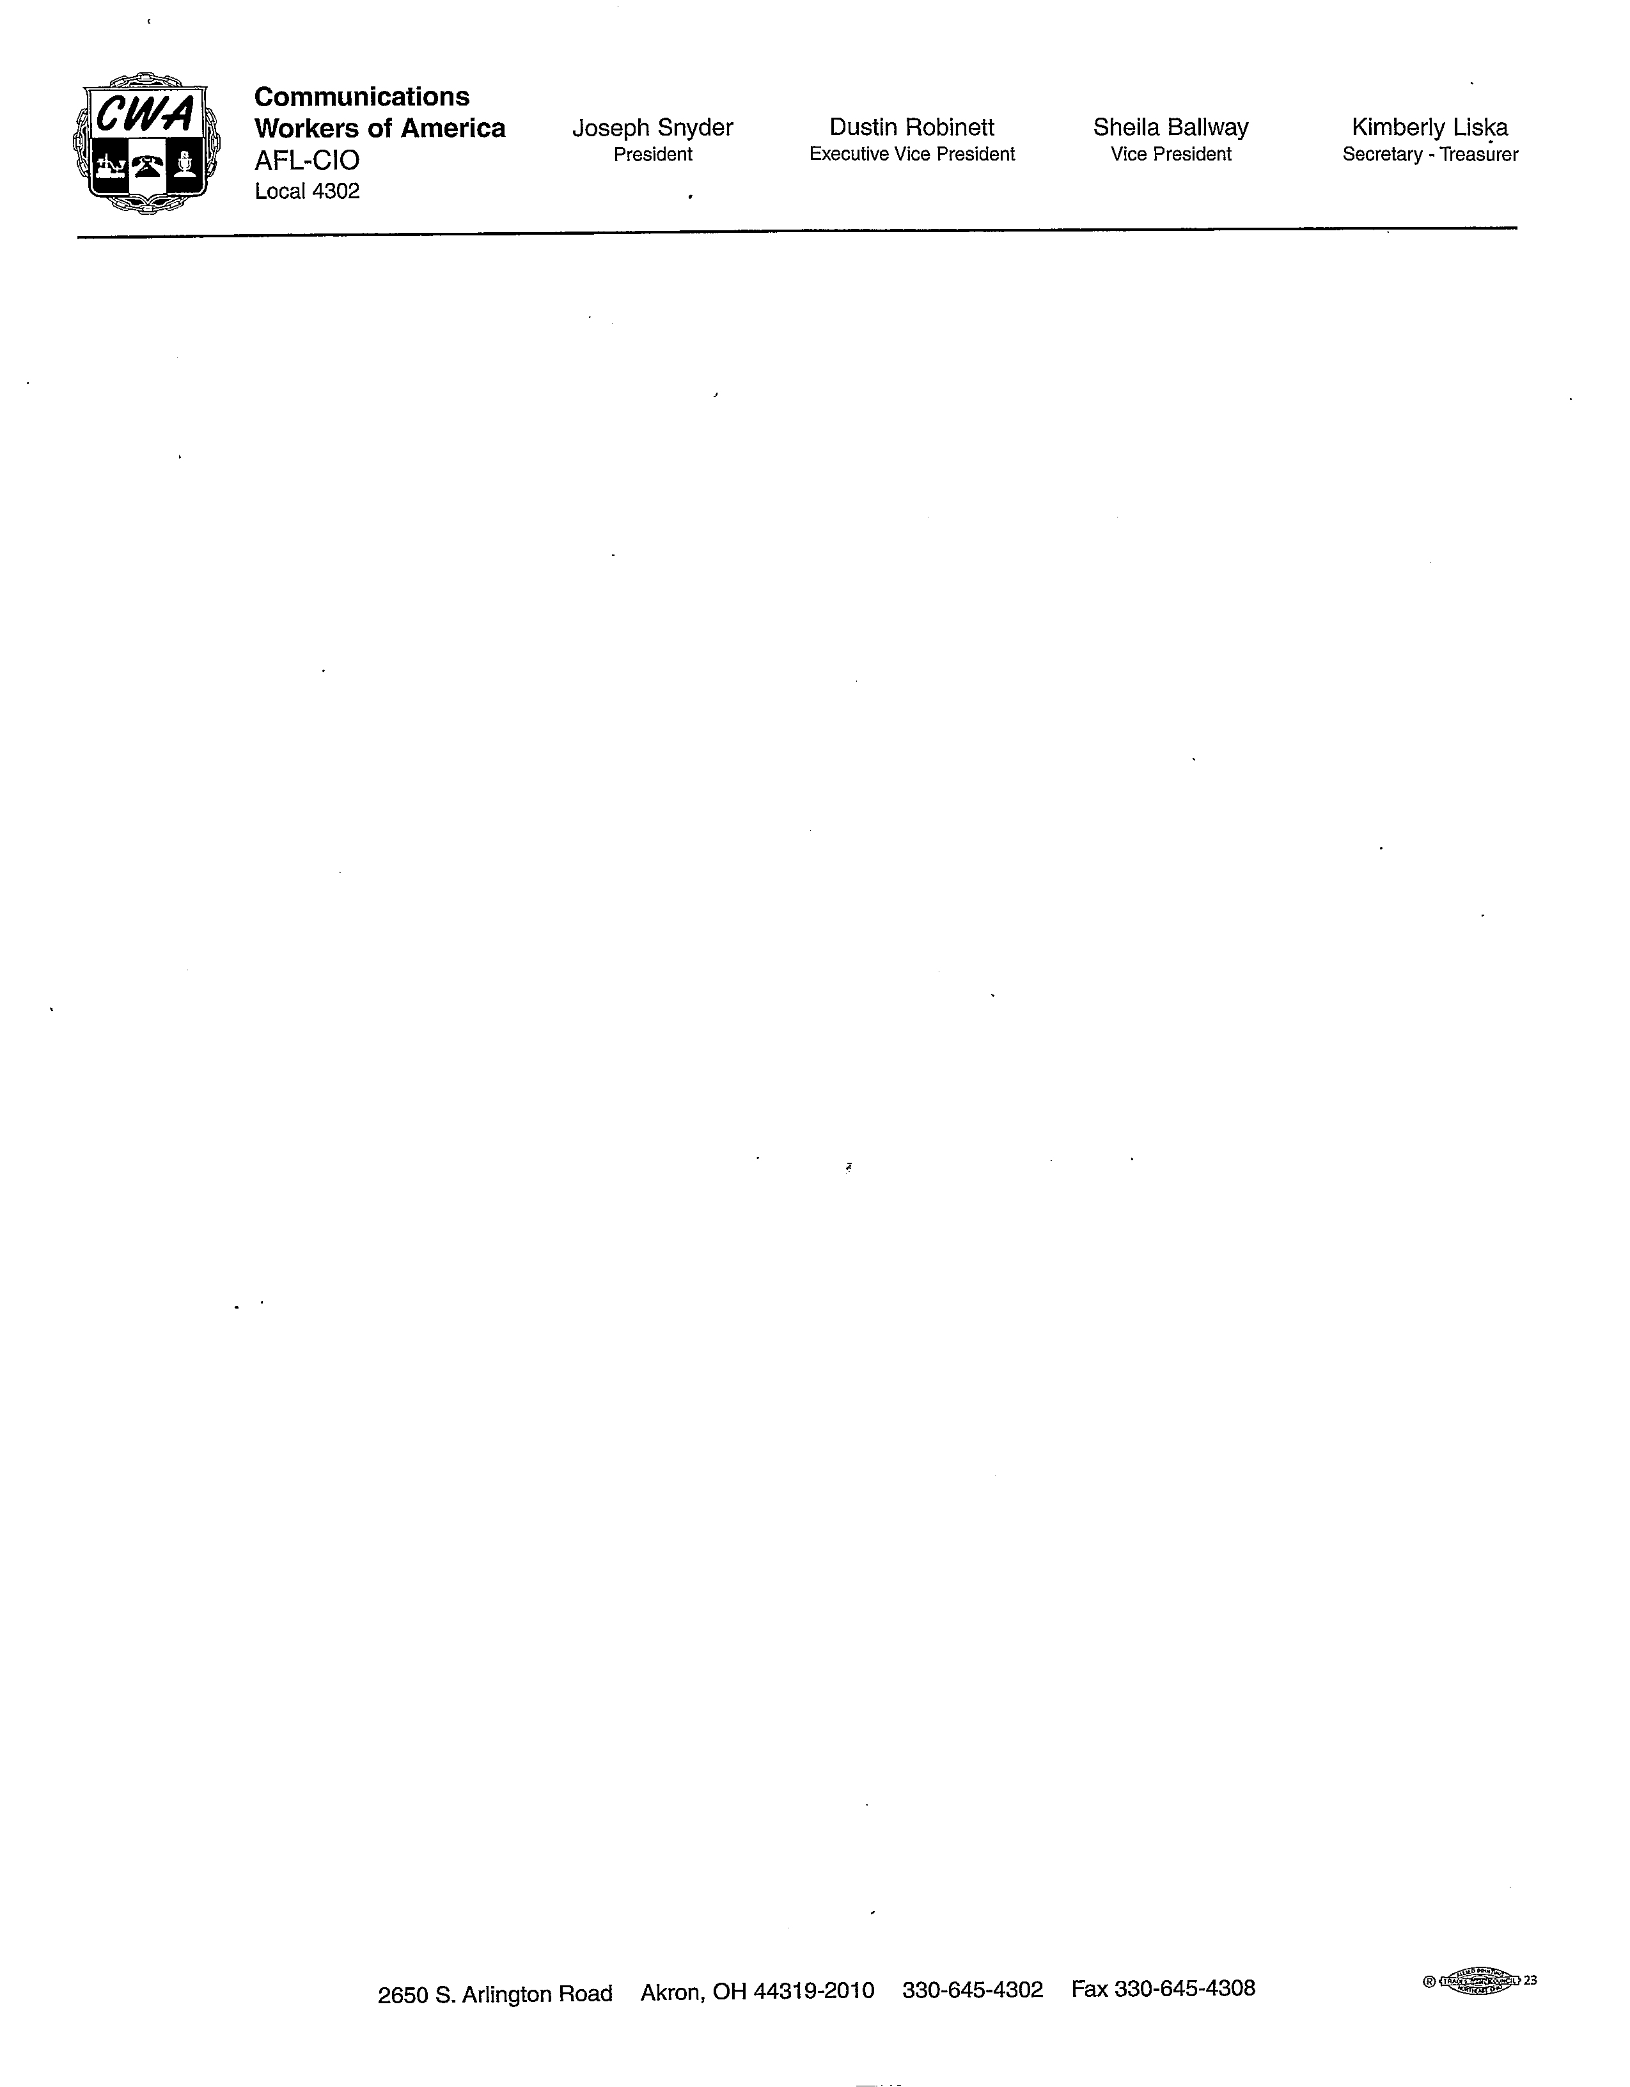

\*\*\*\*\*PLEASE POST\*\*\*\*\*

CWA LOCAL 4302

JULY 2023

MEMBERSHIP MEETING

CANCELLED DUE TO

CWA CONVENTION

IN ST LOUIS